Task 2
Select ONE prototyping approach (Evolutionary Prototyping or Throwaway Prototyping). Develop low-fidelity prototypes for 3 main screens of the system and justify why your chosen approach is more appropriate for this project. [2 marks]

2.1 Selected Approach: Evolutionary Prototyping
For the SAMS project, we selected Evolutionary Prototyping. In this approach, we start by developing the important parts of the system, then users test the prototype and give their feedback. After that, we keep improving it until the prototype become the final working system. The prototype is not deleted like Throwaway Prototyping.
This approach is more suitable for SAMS because:
- SAMS is a new system, so some requirements may not be clear from the beginning. When students and staff test the prototype, they may remember new requirements or ask to change some parts.
- The system has different users, such as students, organizers, and Student Affairs staff. Each user may have different needs, so their feedback will help us improve the screens and functions.
- Some functions need more testing, like the waiting list, QR attendance, eligibility rules, and approving activities. It is better to build these parts early and improve them step by step.
- The prototype can show if the screens are crowded, confusing, or difficult to use. For example, users can test the activity search, seat reservation, and activity management screens before completing the whole system.
- The work will not be wasted because every improved version can be used in the final SAMS system. This is better for our project because the development time is limited.
For these reasons, Evolutionary Prototyping can help us understand the requirements better and build a system that is more useful for the actual users.

2.2 Prototype 1 — Student: Browse Activities
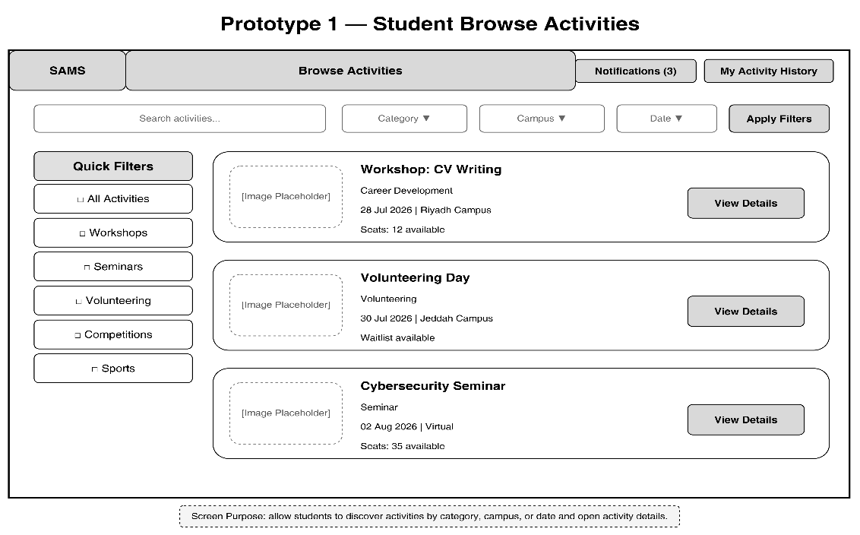
Figure 2 Prototype 1 — Student: Browse Activities

2.3 Prototype 2 — Activity Details and Reservation
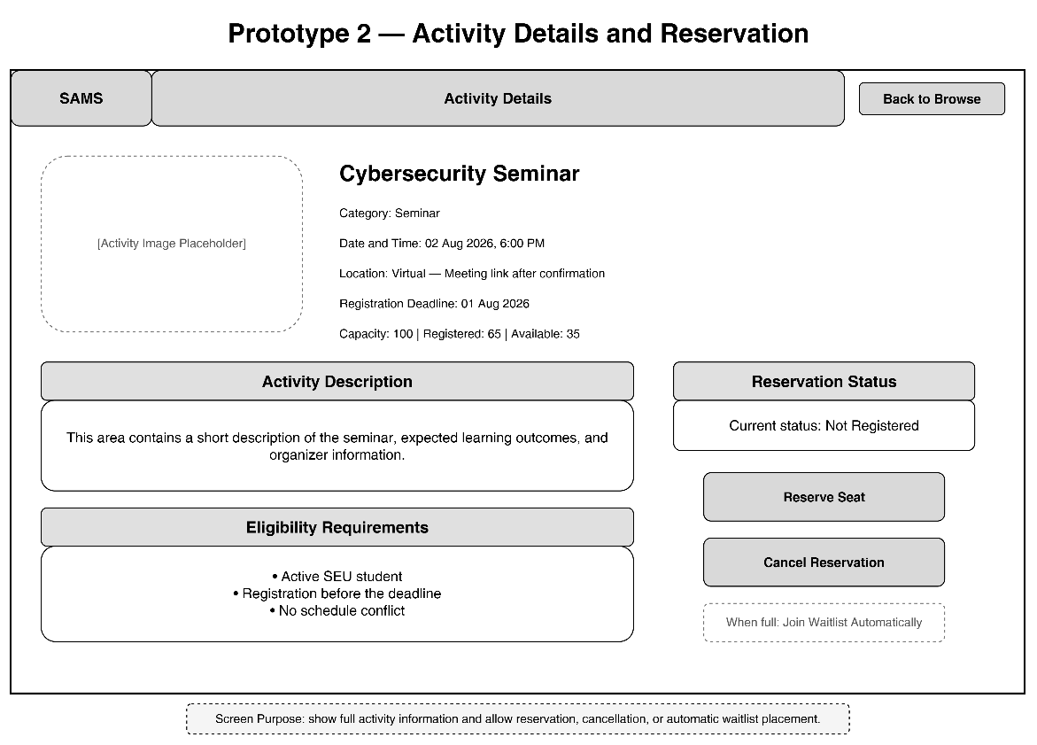
Figure 3 Prototype 2 — Activity Details and Reservation

2.4 Prototype 3 — Organizer Activity Management
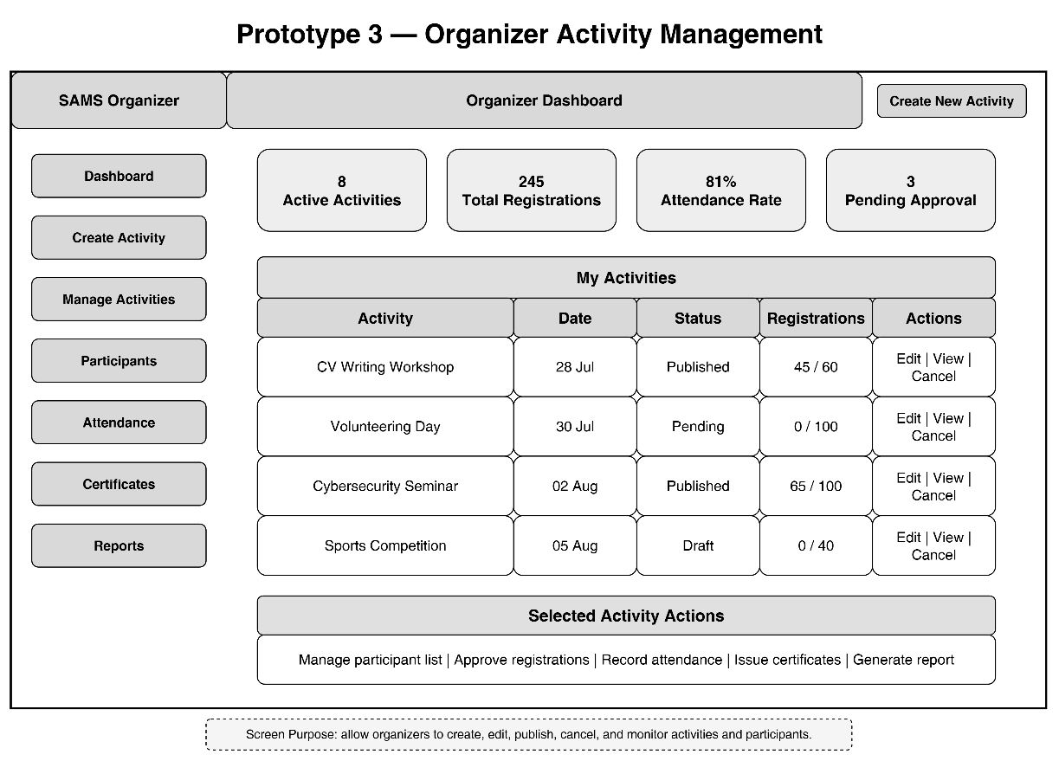
Figure 4 Prototype 3 — Organizer Activity Management

